CALL-project: Developing a native language specific grammar corrector

Celia Medina Gimenez
Business Information Technology
University of Twente
Enschede, The Netherlands
c.medinagimenez@student.utwente.nl
Oskar Piibar
Business Information Technology
University of Twente
Enschede, The Netherlands
o.j.piibar@student.utwente.nl
Pietro Calliari
Business Information Technology
University of Twente
Enschede, The Netherlands
p.calliari@student.utwente.nl
Rahul Nanduri
Business Information Technology
University of Twente
Enschede, The Netherlands
r.s.s.nanduri@student.utwente.nl

Defined Goal

Before taking any actions regarding the data or coding, it is important to define the criteria for a successful or unsuccessful project. In this section, the goals for the project are defined.

The main goal of this project is to develop a language correction model, like Grammarly, grammar corrector for Microsoft Word or Google Docs. However, the difference is that the language correction model takes into account the native language of the speaker and provides a model trained specifically for them. This means that the provided correction for a similar mistake might differ, depending on the native language of the user. However, we are not building a language correction model from scratch as we do not have the computational power for it. We are taking an already existing model and altering it, so it could provide a personalized correction for a group of native language speakers.

A secondary goal of our project is to apply the model. For that a simple website will be built, where the user can choose between a few languages and depending on the language selection, a specific model will be provided. The model will then correct the inputted sentence and ideally mark the made errors.

Motivation
The relevance of the project, contribution to the module and the taught subjects are discussed in this section.
The amount of English as a Second Language (ESL) speakers is already bigger than the number of native English speakers [1]. All of the members of our group are also part of the ESL speakers. It was found that the grammatical error correction (GEC) models do a better job at correcting English as a Second Language (ESL) text when using a corpora written by learners of ESL, rather than a native English corpora [2]. This is due to the fact that the errors made by non-native English speakers are mostly systematic and can be traced back to the habits they have from their first language [2].
Building a GEC model that takes into account ESL corpora requires knowledge in different areas, which are mostly part of our module. It requires knowledge about machine learning for data types to alter existing GEC models to our needs. The data for training the model needs to be preprocessed according to the principles of data quality. Each project that deals with input from a human needs to consider ethical risks and respective mitigations. The model and its functioning is necessary to be understood by humans, which integrates explainable artificial intelligence into this project. Lastly, the model needs to be used outside of the command line, which requires web development skills and integration of the previously acquired knowledge.

Ethical Perspective and Framework Application
A natural language processing task inherently brings risk to violating conventional ethics. Collecting data from online forums without obtaining explicit consent from users can infringe on privacy rights and violate data protection laws like GDPR. Furthermore, the dataset may contain biases if certain native languages are overrepresented, leading to unfair or less accurate corrections for speakers of underrepresented languages. The model could consequently inadvertently reinforce negative stereotypes by associating specific grammatical errors with particular language groups, potentially stigmatizing users when we attach it to our web application. Without transparency about how data is collected and used, users may lose trust in the system, especially if they are unaware of the ways their data contributes to the model, and there is the significant risk that technology could be misused in discrimination or unfair profiling of non-native speakers based on their language patterns.
During our data manipulation process, we were attentive to several ethical aspects to ensure our project met high standards of integrity. Starting with a dataset of 80,000 entries containing users' native language, language proficiency, and written text, we took steps to protect user privacy and adhere to ethical guidelines regarding human subject data [3]. This involved removing special characters, emoticons, sentences shorter than three sentences, empty text entries, and non-English sentences, thereby anonymizing the data as much as possible and eliminating potentially sensitive information. This also allowed us to level the playing field for over-represented and under-represented languages by volume.
We recognized the potential for bias in our dataset [4]. We selected the two languages with the most data—Spanish, and Chinese (Mandarin). This allows us to get a broad overview of the types of grammatical mistakes made by non-native English speakers. However, we were conscious that focusing on these languages alone might overrepresent certain groups. To address this, we documented our data sources and preprocessing steps thoroughly to maintain transparency and allow for scrutiny of our methods.
Moreover, we employed methods such as part-of-speech (POS) tagging and error frequency analysis to understand and classify error patterns without attributing them to inherent deficiencies in any language group, thus avoiding the reinforcement of negative stereotypes [5]. Our extraction methods—based on relative frequencies, error-prone POS-tag sequences, and error positions—were designed to enhance the model's ability to provide accurate corrections and helpful feedback, ensuring fairness and inclusivity in our approach.

Method
In the following section we will discuss our planning, the data, steps we took during data preprocessing and the algorithms used.

Planning
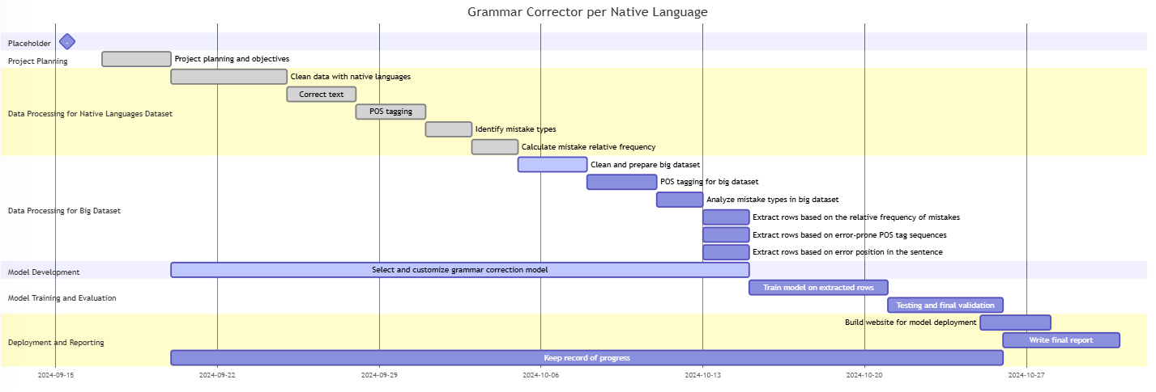
- Gantt chart of grammar correction model development.
In the figure above Fig. 1 a Gantt chart of the project has been displayed. The first major phase after the project planning consists of the data preprocessing of both a native language specific dataset and a larger general dataset. For both, the subtasks are similar except for the text correction which is only necessary for the language specific dataset. Overlapping with the actions on the datasets is the tailoring of a native-specific language correction model. Once both of those phases are complete, the model is trained with the extracted rows. Then, it’s tested and validated. The final phase involves creating a website for the model’s deployment and writing the report.

Data Manipulation
Our initial native language specific dataset consisted of 80 thousand rows, where the native language, their language proficiency and written text were included. For the data preprocessing all special characters, emoticons, sentences shorter than 3 sentences, empty text entries and non-English sentences were removed. Afterwards, the data was filtered based on the native language of the writer. We selected two languages, Spanish, Chinese (Mandarin), which had the most rows, to get a broad overview of the types of mistakes. We corrected these text entries using a grammar correction found from Huggingface [6]. Following that, we ran a part-of-speech (POS) tagging algorithm on both the incorrect and correct text, which assigns each word with a tag, like ‘PRON’ for pronoun or ‘ADJ’ for adjective. Running it on both text columns allowed us to compare the POS-tags and determine the mistake types of the sentences. Following that we counted the errors, which was necessary for a relative frequency calculation. From here onwards we used three different methods to extract rows, which will be in detail described in the technical depth section, from a bigger dataset to later use for the training of our different models.
The given dataset was too small and included very arbitrary conversations. Training a language correction model on that dataset would not have yielded good results. Therefore we needed a bigger dataset, that consisted of two columns, the text and its correction, which we found from Lang-8 Learner Corpora [7]. On the big dataset we also ran a POS-tagging algorithm, classified the errors and counted them. Now both of the datasets were ready for row extractions.

Model
Building a model from the scratch, specifically for our needs is computationally too demanding and not feasible with the available options. Therefore, we decided on an approach where we fine tune an existing model built for natural language processing. Looking at existing models, primarily explored pretrained models like BERT, T5, and GECToR, which are suitable for grammar correction. BERT’s contextual understanding, T5’s versatility, and GECToR’s specialization in grammatical error correction made them ideal choices. BERT, being an encoder-only model, is proficient in understanding text but lacks the capability to generate corrected sentences, which is essential for our application. GECToR, while tailored for grammatical error correction using an edit-based approach, is limited in producing comprehensive corrections and providing explanatory hints to learners [8]. We ultimately selected T5, an encoder-decoder model, because it excels in both understanding and generating text. Its text-to-text framework effectively handles the sequence-to-sequence nature of grammatical corrections. Training T5 on our dataset gives us the perfect sweet-spot between natural language processing for understanding, training and testing. Within T5, there are several ‘classes’ of model robustness to choose from. We chose the t5-base model specifically because it strikes a balance between performance and computational efficiency, providing robust capabilities without the prohibitive computational costs associated with larger T5 variants.
In the Technical Depth section, we will analyze the functioning of the model and its settings.

Technical Depth
In this section we will go deeper into the data extraction methods and discuss the working of our model.

Data Extraction
We performed data extraction from the bigger file in three different ways. Firstly, we extracted the rows from the bigger dataset based on the relative frequencies of the mistakes. This was a chosen method because it matches the error types per language and provides a good representation of the mistakes made by a specific language speaker. If the frequency was matched at a 90% confidence interval, then the correct and incorrect text of that entry were saved separately and classified suitable to train a specific language model.
Secondly, we used the most error prone POS-tag sequences to extract the rows. This method located where the error was and took the two adjacent POS-tags and saved this sequence with a count. We then extracted 4 highest count sequences for each language and if the specific sequence was matched with the same sequence in the big dataset, then it extracted the row with a respective language tag. This approach was chosen because error-prone sequences are language-specific, allowing us to target and extract rows that reflect recurring structural patterns and common mistakes unique to each language group.
Lastly, we used error positions to extract rows from the big dataset. For this approach, we identified the section where a mistake occurred: if within the first or last 20%, it was categorized as "beginning" or "end," respectively, while errors in the middle 60% were classified as "middle”. Later rows were extracted from the big dataset where the errors were made in similar places. This approach was chosen to enhance model robustness; errors at the beginning or end require focused, localized corrections, while mid-sentence errors demand an understanding of the entire sentence context.

Model Analysis
For starters we chose the T5-base model because it has a moderate number of parameters (220 million) and layers (12), instead of T5-small that has a lot less parameters (80 million) and layers (6) or T5-large that has too many parameters (770 million) and layers (24) [9]. This way we are able to complete our task without having to spend too much time and computational power that we, even though we used the university servers for this project, do not have.
For the correct training of the model we uploaded the tailor-made dataset for the specific learner native language that we wanted to correct in a pandas data frame. For T5-base to work we needed to make two specific modifications to this data frame: firstly, we needed to have an input and target column, so we changed the name of the columns accordingly, secondly, we needed to add at the beginning of each input row the tag “grammar: “. This is done because T5 models can perform multiple tasks like translation, using “translate English to Dutch:“ for example, and summarization, using "summarize: ", with a single model, and the unique prefix is used for each task so that the model knows which task to perform [10]. We then proceed to split the data frame for training and evaluation
For training we used HappyTextToText from the happytransformers library because it is built on Hugging Face Transformers, it is very efficient with T5 models and outputs clear evaluations metrics [10]. We used a batch size of 4, as it was the largest number before encountering memory issues, we reduced the max input and output length to 32, since there weren't many sentences longer than this, and used only one epoch for not getting too long training times. At the end of the training we saved each model using pickle for then being able to use it to generate corrections on the web app.

Results
The evaluation shows clear results of a steady decrease for both training and validation loss. This indicates that the model is learning effectively, although after the initial big drop, there is a major decrease of the learning rate Fig. 2. We can also notice the loss plateauing from the half point on showing that it has reached its limits. We tried with different data quality techniques on the input data and we made some slight changes in the training arguments and our best results are shown in the figure below Fig. 2.
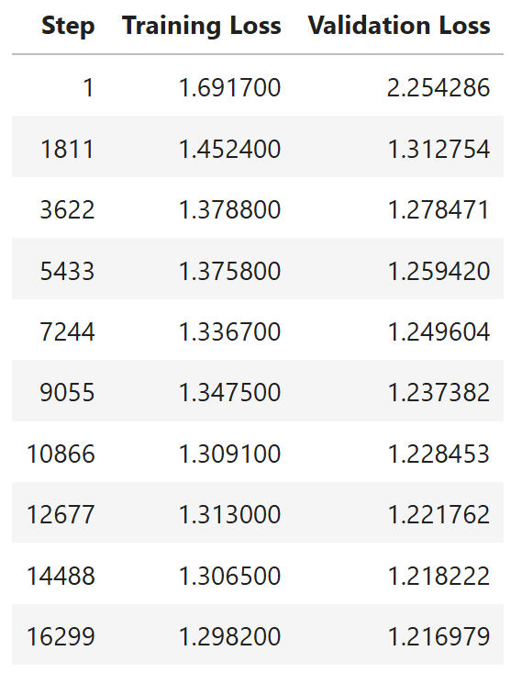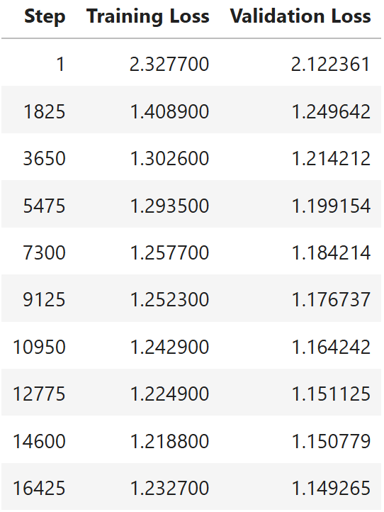
- Training loss and validation loss for Spanish (left) and Chinese (right) models.
Both models have reached very good results with having no overfitting or underfitting issues and are capable of correcting sentences with grammatical errors. To show that we can take the model out of a jupyter notebook and use it in a real-life situation, we created a simple web app with a text input field, a ‘correct’ button and two output fields, where the correct sentence is displayed and the corrected mistakes are analyzed and explained through the model behavior and error statistics.

Conclusions

Application of Module Components

Using the Template

Identify the Headings
Headings, or heads, are organizational devices that guide the reader through your paper. There are two types: component heads and text heads.
Component heads identify the different components of your paper and are not topically subordinate to each other. Examples include Acknowledgments and References and, for these, the correct style to use is “Heading 5”. Use “figure caption” for your Figure captions, and “table head” for your table title. Run-in heads, such as “Abstract”, will require you to apply a style (in this case, italic) in addition to the style provided by the drop down menu to differentiate the head from the text.
Text heads organize the topics on a relational, hierarchical basis. For example, the paper title is the primary text head because all subsequent material relates and elaborates on this one topic. If there are two or more sub-topics, the next level head (uppercase Roman numerals) should be used and, conversely, if there are not at least two sub-topics, then no subheads should be introduced. Styles named “Heading 1”, “Heading 2”, “Heading 3”, and “Heading 4” are prescribed.

Figures and Tables

Positioning Figures and Tables: Place figures and tables at the top and bottom of columns. Avoid placing them in the middle of columns. Large figures and tables may span across both columns. Figure captions should be below the figures; table heads should appear above the tables. Insert figures and tables after they are cited in the text. Use the abbreviation “Fig. 1”, even at the beginning of a sentence.
- Table Type Styles
Table Head | Table Column Head
 | Table column subhead | Subhead | Subhead
copy | More table copyª
- Sample of a Table footnote. (Table footnote)
- Example of a figure caption. (figure caption)
Figure Labels: Use 8 point Times New Roman for Figure labels. Use words rather than symbols or abbreviations when writing Figure axis labels to avoid confusing the reader. As an example, write the quantity “Magnetization”, or “Magnetization, M”, not just “M”. If including units in the label, present them within parentheses. Do not label axes only with units. In the example, write “Magnetization (A/m)” or “Magnetization {A[m(1)]}”, not just “A/m”. Do not label axes with a ratio of quantities and units. For example, write “Temperature (K)”, not “Temperature/K”.

Acknowledgment (Heading 5)
The preferred spelling of the word “acknowledgment” in America is without an “e” after the “g”. Avoid the stilted expression “one of us (R. B. G.) thanks ...”. Instead, try “R. B. G. thanks...”. Put sponsor acknowledgments in the unnumbered footnote on the first page.

References
- Ronowicz, E., & Yallop, C. (2007). English : one language, different cultures. Continuum.
- Liu, Y. (2023). Grammatical Error Correction Incorporating First Language Information. Figshare. https://doi.org/10.25949/23897178.v1
- Metcalf, J., & Crawford, K. (2016). Where are human subjects in big data research? The emerging ethics divide. Big Data & Society, 3(1), 1–14. https://doi.org/10.1177/2053951716650211
- Bender, E. M., & Friedman, B. (2018). Data statements for natural language processing: Toward mitigating system bias and enabling better science. Transactions of the Association for Computational Linguistics, 6, 587–604. https://doi.org/10.1162/tacl_a_00041
- Hovy, D., & Spruit, S. L. (2016). The social impact of natural language processing. Proceedings of the 54th Annual Meeting of the Association for Computational Linguistics (ACL), 591–598. https://doi.org/10.18653/v1/P16-2096
- vennify/t5-base-grammar-correction · Hugging Face. (2024, February 6). Huggingface.co. https://huggingface.co/vennify/t5-base-grammar-correction
- NAIST Lang-8 Learner Corpora. (n.d.). Sites.google.com. https://sites.google.com/site/naistlang8corpora/
- Raffel, C., Shazeer, N., Roberts, A., Lee, K., Narang, S., Matena, M., Zhou, Y., Li, W., & Liu, P. J. (2020). Exploring the Limits of Transfer Learning with a Unified Text-to-Text Transformer. Journal of Machine Learning Research, 21(140), 1–67. https://jmlr.org/papers/v21/20-074.html
- google-t5 (T5 community). (2024, February 14). Huggingface.co. https://huggingface.co/google-t5
- Fine-Tune a Transformer Model for Grammar Correction. (2021, August 18). Vennify Inc. https://www.vennify.ai/fine-tune-grammar-correction/

We suggest that you use a text box to insert a graphic (which is ideally a 300 dpi TIFF or EPS file, with all fonts embedded) because, in an MSW document, this method is somewhat more stable than directly inserting a picture.
To have non-visible rules on your frame, use the MSWord “Format” pull-down menu, select Text Box > Colors and Lines to choose No Fill and No Line.

